**List and explain different types of managers.**

## Types of managers/ level of managers/ types of management

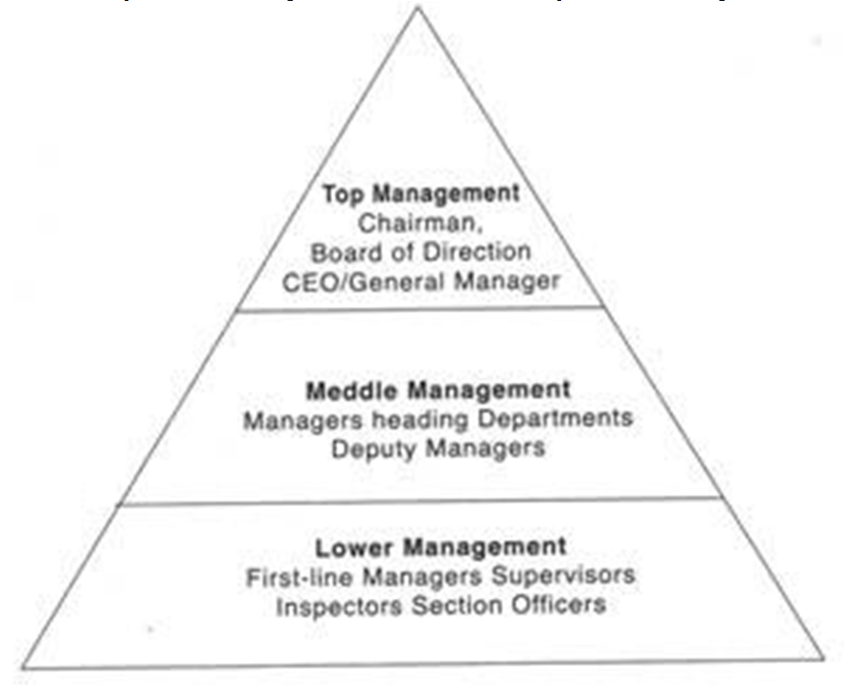

*Top level management*

* It consists of board of directors, chief executive or managing director.
* The top management is the ultimate source of authority and it manages goals and policies for an enterprise. It devotes more time on planning and coordinating function.
* It controls & coordinates the activities of all the organization.
* It prepares strategic plans & policies for the enterprise. It also provides direction.
* They also maintain the contacts with outside world.

## Middle level management

* The branch managers and departmental managers constitute middle level. They devote more time to implement policies and strategies.
* They make plans for the sub-units of the organization.
* They interpret and explain policies from top level management to lower level.
* They also send important reports and other important data to top level management.
* They are also responsible for inspiring lower level managers towards better performance.

## Lower level management

* Lower level is also known as supervisory / operative level of management.
* It consists of supervisors, foreman, section officers, superintendent etc.
* They are responsible for the quality as well as quantity of production.
* They communicate workers problems, suggestions, and other recommendation etc. to the higher level and higher level goals and objectives to the workers.
* They help to solve the grievances of the workers.
* They are responsible for providing training to the workers.
* They arrange necessary materials, machines, tools etc. for getting the things done.
* They prepare periodical reports about the performance of the workers.
* They ensure discipline in the enterprise as well as motivate workers.

# List and explain the roles of manager. OR

**Explain the role of manager as per Mintzberg. OR Explain Mintzberg managerial role.**

* These roles can be grouped into three categories

1. Interpersonal role
2. Informational role
3. Decisional role

Provide Information

Decisional

Informational

Interpersonal

Process Information

**Feedback**

Use Information

## Interpersonal role

##### Figurehead

* + In the figurehead role, the manager is a symbol and represents the organization in matters of formality.
  + He / She performs official duties such as the signing of legal documents on behalf of the company, participation as a social necessity to greet visitors and customers and being available for people / agencies that will only deal with him / her because of status and authority.

##### Leader

* + The leader role is to motivating and directing their subordinates.
  + The manager also looks after the interest of his subordinates and also tries to solve their work related problems.
  + He also sets goals / objectives for his followers, co-ordinates the individual goals with the organizational goals.

##### Liaison

* + The liaison role is to get connected between organization and outsiders.
  + They have to interact with peers and people outside of the organization.
  + The manager’s networking skills to maintain internal and external contacts for information exchange are essential.
  + The top level manager uses the liaison role to gain favors and information, while the supervisor uses it to maintain the routine flow of work.

## Informational role

##### Monitor

* + In the monitor role, the manager must establish and maintain information system; by building contacts both within and outside the organization and training staff to deliver information.

##### Disseminator

* + In the role of disseminator, the manager receives, interprets, and transmits external information through the liaison role into the organization and internal information through the leader role between subordinates.

##### Spokesman

* + In the role of spokesperson, the manager disseminates the organization’s information into the general public, such as customers, suppliers, government and the press.

## Decisional role

##### Entrepreneur

* + In the entrepreneur role, the manager initiates and plans the controlled change in the organization through exploiting opportunities or solving problems and taking action to improve existing operation.

##### Disturbance Handler

* + In the disturbance handler role, the manager reacts to spontaneous situations and unpredictable events which pose threats to the organization and must take action to correct the situation.

##### Resource Allocator

* + In the resource allocator role, the manager decides where the organization will expand its efforts and makes choices on the allocation of resources such as capital fund, time, materials and manpower.

##### Negotiator

* + In the negotiator role, the manager negotiates on behalf of the organization with other individuals or organizations for a new sales contract or cooperation agreement.